EPCE 6205 Mid-term Exam. Jan 06, 2023. ASTU

1. Consider the following system: The signal flows according to the arrow ( “C” element’s signal flows only through up and down, which is different in the previous HA). The failure of any single element in the system is independent of failures in any of the other systems. The probability for each individual system is

$$P\left(A\right)=P\left(D\right)=0.01, P\left(C\right)=P\left(F\right)=0.02$$

$$P\left(B\right)=P\left(E\right)=0.03, P\left(G\right)=0.001$$

What is the probability of failure for the entire system?

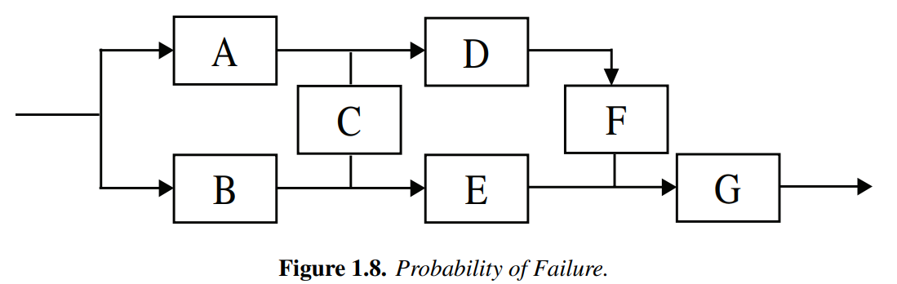

1. Consider two sample spaces of the probability

$$Mind=\left\{happy, sad\right\}, Weather=\{sun, rain, fog\}$$

Then joint probabilities are given in the table as

|  |  |  |  |
| --- | --- | --- | --- |
|  | sun | rain | fog |
| happy | 0.4 | 0.05 | $$P\left(happy∩fog\right)$$ |
| sad | 0.2 | 0.2 | 0.05 |

2.1) Find $P\left(happy∩fog\right)$

2.2) Find $P(fog | sad)$

1. An airplane is flying in the sky. To measure the height of the airplane, two measurement devices are available. One is an altimeter in the airplane and the other is a radar on the ground. The characteristics of two devices are

$$altemeter \sim N\left(m_{a}, σ_{a}^{2}\right) , radar \sim N( m_{r}, σ_{r}^{2})$$

To estimate the height of the airplane, two measurements are used, Let us define $(X,Y)$ are random variables for height of altimeter and radar, which are independent each other. Define an estimator to be the sum of two random variables with appropriate weightings

altemeter

radar

* 1. Find the variance of $z$
  2. Find $a^{*}, b^{*}$ to minimize the variance
  3. Define

$$ρ= \frac{σ_{a}^{2}}{σ_{r}^{2}}$$

If $ρ→0$, what value of $z^{*}(=a^{*}X+b^{*}Y)$ does converge to?

* 1. If what value of $z^{*}(=a^{*}X+b^{*}Y)$ does converge to?
  2. Rewrite the minimum variance estimator is

$$Z^{*}=a^{*}X+\left(1-a^{*}\right)Y=X+K\left(Y-X\right)$$

Then prove that if $Y \sim N(0, σ_{y}^{2}$), the gain $K$ is equivalent to the Kalman gain

1. Consider a joint RV whose pdf is
 $$f_{Z}\left(z\right)= \left\{\begin{aligned}\frac{1}{2} x≥0, y≥0 , x+y≤2 \\ 0 otherwise\end{aligned}\right.$$

  1. Verify $\int_{-∞}^{∞}{f\left(z\right)dz=1}$
   2. Find the marginal pdf of x and y , i.e. $f_{X}\left(x\right)$ and $f_{Y}(y)$
   3. Find $f(x|y)$ and verify $\int_{-∞}^{∞}{f\left(x | y\right)dy }=1$
   4. Find $E[X]$ and $E[X|y=1.5]$-The End-